

**SPURING PUBLIC PARTICIPATION THROUGH POWERING REAL TIME INFRASTRUCTURE DISCLOSURE**

**DATA ANALYTICAL REPORT**

**JUNE 2023**

**ACRONYMS**

CoST The Infrastructure Transparency Initiative

FY Financial Year

GOU Government of Uganda

GPP Government Procurement Portal

LG Local Government

MDAs Ministries, Departments and Agencies

MoFPED Ministry of Finance, Planning and Economic Development

OC4IDs Open Contracting for Infrastructure Data Standard

PDE Procuring and Disposing Entity

PDE Procuring and Disposing Entity

PDU Procurement and Disposal Unit

PPDA Public Procurement and Disposal of Public Assets Authority

UNRA Uganda National Roads Authority

# **Acknowledgement**

CoST Uganda expresses its appreciation to the Government of Uganda through the Ministry of Works and Transport, the Champion of CoST in Uganda, for its stewardship of the programme.

We are also grateful to the Ministry of Finance, Planning and Economic Development and PPDA for enabling us access to the Government Procurement Portal (GPP), discussion on the Electronic Government Procurement Portal (EGP) and engaging in interviews to inform this infrastructure procurement analysis and the design of the Infrastructure Analytical Dashboard.

We are indebted to the United Kingdom’s Foreign Commonwealth Development Office (FCDO) through the CoST International Secretariat, without whom this assignment would never have been achieved. We also appreciate our host organization, the Africa Freedom of Information Centre who has provided us all the necessary administrative and financial management support to deliver CoST activities in Uganda. Lastly, we thank our Resource Team including Dr. Levi Kabagambe, Mr. Michael Cengkuru who produced this report and the analytical tool and, the OC4IDS help desk, CoST Team including the OC4IDS help desk, Ms. Evelyn Hernandez, Ms. Olive Kabatwairwe and Mr. Geoffrey Odong for reviewing the products.

We recognize the value of verifying government data before publication as a critical process of ensuring credibility and validity of information to be consumed by stakeholders and the general public. We therefore affirm that this report presents correct information as validated by key stakeholders through the interviews undertaken by our Resource Team. We encourage stakeholders and the general public to make good use of the information in this report and for relevant actors to address the recommendations.

Thank you all for your contributions towards the realization of quality infrastructure, a stronger economy and better lives in Uganda.

# **TABLE OF CONTENTS**

**Acknowledgement** III

**TABLE OF CONTENTS** IV

**LIST OF TABLES** V

**1.0 EXECUTIVE SUMMARY** 2

**2.0 ABOUT THE INFRASTRUCTURE TRANSPARENCY INITIATIVE – CoST** 3

**3.0 METHODOLOGY** 4

**3.1 Analytical Dashboard Development** 4

**3.2 Use Cases Identification** 5

**3.3 Analysis of Disclosed Data** 6

**3.4 Integration of OC4IDS in EGP** 7

**4.0 RESULTS AND INTERPRETATION** 8

**4.1 Analytical Dashboard Development** 8

**4.2 Use Cases Identification** 8

**4.3 Analysis of Infrastructure Disclosure Practices** 10

4.3.1 Overall summary 10

4.3.2 Average number of bids per tender for competitive methods 11

4.3.3 Awards by Procurement Method 11

4.3.4 Bidders by nationality 12

4.3.5 Most frequently winning providers per PDE 13

4.3.7 Percentage of tenders with less than three bids 16

4.3.8 Variations in award price and market price 16

**4.4 Integration of OC4IDS in EGP** 18

**5.0 SUMMARY OF KEY FINDINGS** 21

**6.0 SUGGESTED RECOMMENDATIONS** 22

**7.0 REFERENCES** 24

# **LIST OF TABLES**

**Table 1: Use area and indicators** 6

**Table 2: Bidders by nationality** 12

**Table 3: Most frequent winning providers per PDE** 13

**Table 5: Contracts whose Award Value is greater that the Market Price** 17

**Table 6: OC4IDS Project Level information** 19

**Table 7: OC4IDS Contract level information** 20

**LIST OF FIGURES**

Figure 1 : Number of bids received by procurement method 11

Figure 2 : Awards by Procurement method 12

Figure 3 : Most frequent winning providers per PDE 14

Figure 4 : Most frequently losing providers per PDE 16

# **1.0 EXECUTIVE SUMMARY**

This report presents an analysis of disclosed infrastructure data through the Government Procurement Portal (GPP). The analysis sought to understand the performance of 131 projects worth UGX 357 billion from 13 selected entities against set indicators; identify areas of improvement and possible use cases to guide integration of the Open Contracting for Infrastructure Data Standard within the Electronic Government Procurement Portal in partnership with the Ministry of Planning and Economic Development. The analysis was based on selected indicators covering the following broad use areas: performance monitoring, bench-marking performance; transparency reports; supplier analysis; and other OC4IDs Red-flags.

The key indicators computed for this purpose include delays, cost overruns, frequent bid winners and losers, local（% local contractors, procurement method used, variations, and competition (open tenders with less than 3 bids). Data for the analysis was based on procurement data proactively or reactively disclosed on the existing infrastructure data section for the period 2020-2023 as disclosed by Procuring and Disposing Entities (PDEs) on the Government Procurement Portal (GPP). The Portal is managed by the Public Procurement and Disposal of Public Assets Authority (PPDA). Consequently, the respective indicators were computed using pre-defined mathematical operations. The results were presented by constructing output tables and percentages as the case may be. These outputs are interpreted to provide insight from the data.

The analysis of performance of selected entities on set indicators revealed that, on average, the number of bids per tender for the period under review (2020-2023) was 1.38 bids, which was low, suggesting limited competition in the procurement process. Relatedly, most contracts (75%) were awarded through the open domestic bidding method, suggesting a progressive development of local capacity among local contractors. Most bidders (94.5%) during the period under review were Uganda firms, with Lusa construction & Engineering Co. Ltd winning 38 contracts in Uganda National Roads Authority (UNRA), however, the firms that lost most of their bids were TMS Engineering Ltd (in UNRA, having lost nine times) and Munda Holdings Ltd (three times, in Kiboga District Local Government). It could not be established whether these bidders had been d**ebriefed on the causes of their** **poor performance and what they needed to do to reverse the negative trend. Thirty nine percent (39%), that is, about four in 10 tenders had attracted** less than three bids, suggesting low bidder response to tenders. Cases of variation between market price and contract award prices were established as well (Table 5), where a project (Design and Build of Kisoro - Rubuguri - Muko/Nteko Road Upgrading Project (72km) had a variation of up- to 72.8 Bn (14%).

The progress to integrate Open Contracting for Infrastructure Data Standard (OC4IDS) into the EGP was slow. Yet, the real game-changer for transparency is automation and mandatory disclosure to reduce discretion of officials to determine whether or not, when and what data to disclose. Automation assures data integrity, thereby enabling public participation and minimizing the risk of corruption and fraudulent procurement practices. On their end, PPDA and MOFPED should fast track the integration of the OC4IDS into the EGP to foster data integrity and transparency.

# **2.0 ABOUT THE INFRASTRUCTURE TRANSPARENCY INITIATIVE – CoST**

The Infrastructure Transparency Initiative - CoST is aimed at improving citizen’s lives through promoting the use of the Infrastructure Data Standard (IDS) and the Open Contracting for Infrastructure Data Standard (OC4IDS) for information Disclosure, conducting independent Assurance processes on infrastructure projects, promoting dialogue, trust and stakeholder participation in the delivery of infrastructure projects using the Multi-Stakeholder working and Social Accountability arrangements.

CoST Uganda is a National Chapter of CoST International, a charity based in the United Kingdom. The initiative is built on a tripartite partnership between Government, Private Sector and Civil Society to address the challenges in the construction sector in Uganda. CoST Uganda is Championed by the Ministry of Works and Transport and managed by a National Secretariat hosted by the Africa Freedom of Information Centre (AFIC). In order to inform decision making processes on how infrastructure projects are planned, procured, implemented and maintained; the stakeholders need to know and understand the available data regarding all infrastructure projects. However, this can ably be achieved through an in-depth analysis of data including procurement plans, reports, to identify red flags and concerns for stakeholders. The resulting information can then be used as evidence for decision-making and further planning and advocacy for increased infrastructure transparency and fair business practices between Government and Private Sector. Besides, the analysis would help to ensure that infrastructure projects delivery processes are being done in compliance within the legal and policy framework. The findings would help identify critical problems in the sector, and provide evidence based framework to address the challenges.

Therefore, CoST Uganda, under the intervention, *“Deepening transparency to influence infrastructure performance”* has established analytical features on existing infrastructure dashboards and platforms such as the infra-data, ITI using data from the GPP and EGP; identified use cases to share with stakeholders for consideration; analysed performance of selected entities on disclosure against set indicators and initiated engagements with MoFPED and PPDA to integrate the OC4IDS into the EGP to facilitate real time dislcosure and analysis of infrastructure data to inform decisions.

# **3.0 METHODOLOGY**

## **3.1 Analytical Dashboard Development**

The development of the analytical dashboard followed a structured approach to engender a robust, user-friendly dashboard that provides stakeholders with valuable insights into infrastructure procurement data and supports evidence-based decision-making. Accordingly, the analytical dashboard development process encompassed acquisition and ingestion, data storage and cataloging, data pre-processing and transformation, dashboard design and development, and testing and iteration. The specific actions conducted are enumerated here under;

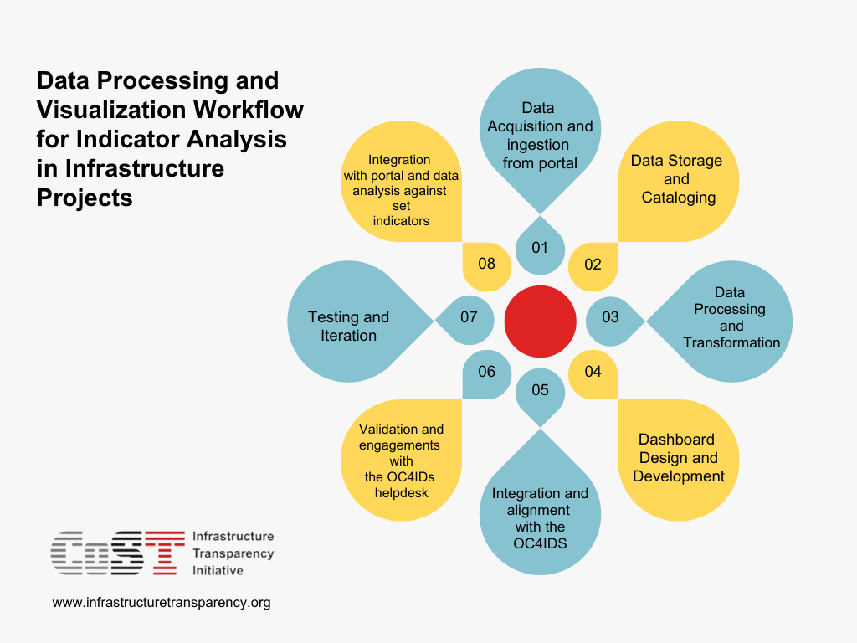

1. Data Acquisition and ingestion from the GPP. This process involved establishing a connection to the portal through APIs and retrieving relevant records for the selected indicators.
2. Data Storage and Cataloging. The acquired data was stored in an external database designed to handle large volumes of data. This database was optimized for fast and efficient querying, enabling the dashboard to deliver real-time insights. The ingested data was cataloged according to the specified indicators to facilitate easy access and analysis. The cataloging process involved data normalization, categorization, indexing, and metadata creation to describe each data element.
3. Data Processing and Transformation. The respective data types were cleaned and subsequently converted to appropriate data types to aid analysis and visualization. Lastly, data aggregation and computations were conducted to derive metrics that align with the specified indicators.
4. Dashboard Design and Development. The process involved creation of wireframes and mockups to support the outline, layout and organization of the dashboard and ensure that the dashboard is intuitive and user-friendly. The resulting data visualization user interface (UI) was developed using modern web technologies and data visualization libraries. The dashboard now enables users to explore the cataloged interactive charts, graphs, and tables. Other features included in dashboard include filters, search functionality, and drill-down capabilities, which allows users to customize their analysis and focus on specific aspects of the data.
5. Integration and alignment with the OC4IDS: The development of the dashboard integrated an alignment with the OC4IDS red flags to ensure consistency.
6. Validation and engagements with the OC4IDs helpdesk: The process further included meetings with the OC4IDS help desk to further validate the dashboard to ensure it complies with international standards.
7. Testing and Iteration. The dashboard functions were tested throughout the development process to identify any bugs and errors. The procedure entailed unit testing, integration testing, and user acceptance testing (UAT) with selected stakeholders. Based on the feedback gathered, necessary adjustments were effected to improve usability, performance, and reliability.
8. Integration with the GPP and data analysis against set indicators

## **3.2 Use Cases Identification**

Use cases demonstrate the potential applications of the analytical dashboard. Therefore, to ensure the analytical dashboard meets the diverse needs of various stakeholders, the following procedure was adopted to identify the use cases. Foremost, government procurement officials, contractors (through Uganda National Association of Building and Civil Engineering Contractors), Consulting Engineers (through Uganda Association of Consulting Engineers), policymakers, and civil society organizations were consulted. The aim was to seek the information needs of contractors for effective decision-making. Besides, the process helped to understand the unique challenges and opportunities faced by the respective stakeholder groups and tailor the dashboard to address their specific needs.

Following the stakeholder consultations, we conducted brainstorming sessions to generate a list of potential use cases. The case evidence was prioritized based on feasibility, impact, and alignment with assignment objectives. The purpose of undertaking these steps was to develop a dashboard that addresses the most pressing needs of stakeholders.

## **3.3 Analysis of Disclosed Data**

In consultation with PPDA, MoFPED, and the CoST Uganda Secretariat, the key indicators of data disclosure were identified. To this end, the analysis used the existing infrastructure data for the period 2020-2023 as disclosed by procuring and disposing Entities (PDEs) on the Government Procurement Portal[1] (GPP) which is managed by the Public Procurement and Disposal of Public Assets Authority (PPDA). The Portal is aligned to the CoST standard, the OC4IDs thus making it the only credible platform with compliant infrastructure data in Uganda. First, disclosed data was checked and cleaned for completeness. The analysis was broadly guided by the information needs or use cases of the respective users: (1) Performance monitoring (PPDA); (2) Bench-marking performance ( PPDA / Ministry of Finance Planning and Economic Development, MoFPED); (3) Transparency reports (Civil society organizations, Accountability agencies, etc.); (4) Supplier analysis (business community); and (5) Red flags (Inspectorate of Government, Office of the Auditor General, etc.); The corresponding specific indicators are presented in Table 1.

**Table 1: Use area and indicators**

|  |  |  |  |
| --- | --- | --- | --- |
| **Use area** | **Indicators** | **Users** | **Remarks** |
| 1. Performance monitoring | Variation | * PPDA * MOFPED | Computed |
| Benchmarking performance | * Spend by procurement category (works, services, supplies) | * PPDA * MOFPED | Not computed. Missing data expenditure on categories |
| Transparency reports | * Delays * Quality of delivered projects | * Accountability agencies - PPDA, IG, OAG, DPP, etc) * CSOs | Not computed. Missing data expenditure on categories |
| Supplier analysis | * Who has been winning frequently ? * Providers/suppliers by category (local content%) | * Business community | * Computed |
| Red-flags | * Procurement method * Variations * Open tenders with less than 3 bids | * Accountability agencies - PPDA, IG, OAG, DPP, etc) * CSOs | * Computed |

## **3.4 Integration of OC4IDS in EGP**

Integrating the Open Contracting for Infrastructure Data Standard (OC4IDS) into the Electronic Government Procurement (EGP) system is crucial in enhancing transparency, accountability, and efficiency within the procurement process. Accordingly, our Resource Team held engagement meetings with MoFPED and PPDA to discuss the integration of the OC4IDS into the EGP and appreciated the need to adopt the following procedure;

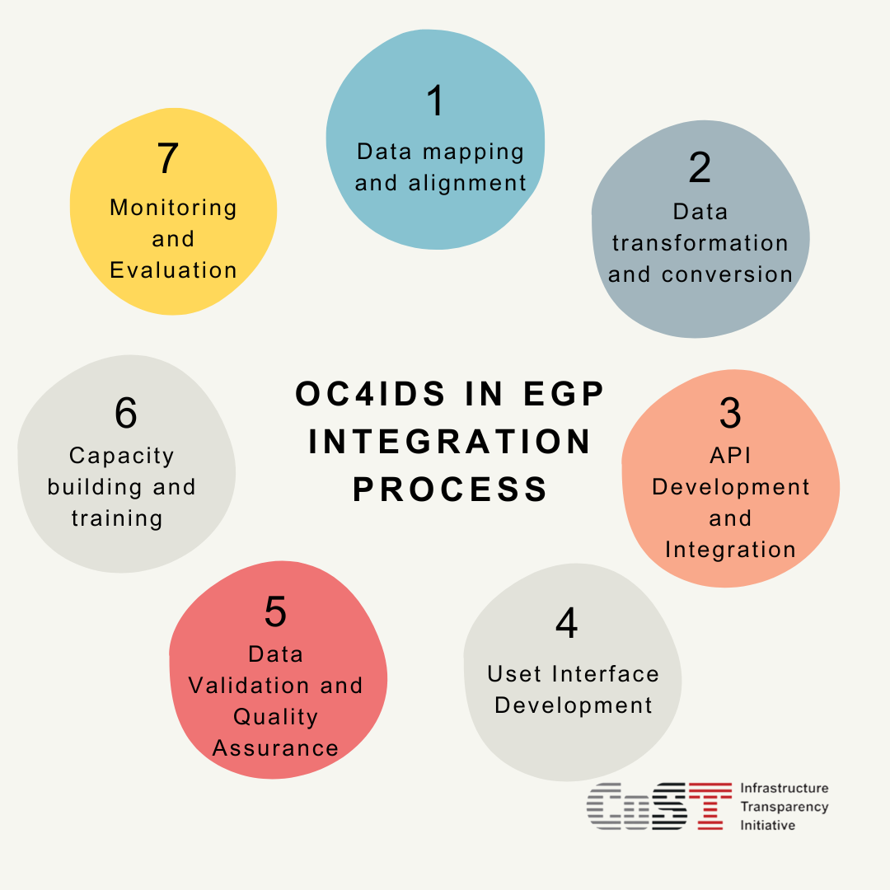

(1) Data mapping and alignment; (2) Data transformation and conversion; (3) API Development and Integration; (4) User Interface Development (5) Data Validation and Quality Assurance; (6) Capacity building and training (to popularize the benefits of OC4IDS integration in EGP); and (7) Monitoring and Evaluation (to track the progress of the OC4IDS integration into the EGP and its impact on the procurement process). This process would be systematic and would require focused resources to ensure effective delivery.

# **4.0 RESULTS AND INTERPRETATION**

## **4.1 Analytical Dashboard Development**

A robust dashboard with analytical features, notably, performance monitoring, bench-marking performance, transparency reports, supplier analysis, and red flags has been developed. The dashboard provides a unified view of the key infrastructure procurement metrics updates in real time and in a single pane. Any change in the underlying data or values will be reflected in the dashboard immediately, thereby making data visualization easier. Similarly, use cases have were identified, including benchmark performance (majorly by MoFPED and PPDA), performance monitoring (by PPDA as the regulator), transparency monitoring by the citizens and Civil Society organizations (CSOs), the media and providers.

*The Analytical Dashboard*

## **4.2 Use Cases Identification**

**Procurement analytics use cases** can be initiated by utilizing dashboards to track **key performance indicators (KPIs)** in order to measure the**impact of decisions** and related activities. Following a structured approach to use case identification, including stakeholder consultation and prioritization, the developed analytical dashboard will address the most critical needs of the users and deliver valuable insights for decision-making. Accordingly, the following use cases are worth mentioning and sharing with stakeholders for consideration.

|  |
| --- |
| **Use Case 1 - Bench-marking performance**  One key task for Procurement professionals is to identify the procurement spend and savings across different procurement items, and **Spend analysis and visibility helps policy makers** to understand what procurements (goods, services or works) are being acquired across the procuring and disposing entities in the country. Through spend analysis one can leverage data analytics to gain detailed insights into procurement activities and spending patterns. **Spend analysis will enable policy makers to pull together government procurement data from all sources to improve efficiency, and build insight to inform future decisions by answering questions such as w**hat is being procured? Whoo is procuring? What is the purpose of the procurement, Who are the providers? Are the requirements being delivered as promised? Quality assured? Fairly priced? Delivered in a timely manner? Therefore, by analyzing historical procurement spend data, Procurement professionals can identify cost-saving opportunities through aggregation of requirements, where possible, both within the entity and between entities to obtain value for money and to reduce procurement cost. |

|  |
| --- |
| **Use Case 2 - Performance monitoring**  Supplier risk is a huge concern for businesses, especially when it comes to the procurement of works, goods and services. There are quite a few suppliers in the marketplace, and therefore it is quite challenging to know which ones are reliable. The goal of supplier risk management is to identify and mitigate risks that may impact a Procuring Entity. By utilizing dashboards, risks on supplier performance help understand key red flags like cost overruns, delays, and project quality issues, entities can assess supplier risk, which is a valuable insight into which suppliers are at risk of influencing or experiencing problems and should therefore be avoided, going forward. Government can therefore use the dashboard to assess the efficiency of procurement processes, identify bottlenecks, and devise strategies to reduce delays and cost overruns. The significance of Performance monitoring data has been underscored in the excerpt… *(when asked what PPDA expects from the dashboard);*  *“As PPDA, we look forward to a simplified, concise, and easy to understand information platform. Public procurement generates too much data, but not all is relevant to all stakeholders alike. For example, bidders want business, period! Their interest is information, especially the estimated cost of the project to enable them prepare bids at or a slightly below cost…”* **[**Senior Performance monitoring officer, PPDA] |

|  |
| --- |
| **Use Case 3 - Transparency Monitoring**  With over 350 Procuring and Disposing Entities (PDEs) under its supervision, PPDA is constrained to efficiently supervise and monitor public contracts. To this end, PPDA has adopted an online Contract Monitoring System (CMS) that permits Civil Society organizations (CSOs) to monitor public contracts to enhance transparency, accountability and value for money. The system is a collaboration between PPDA and CSOs and provides a safe, centralized way to track and manage reports on ongoing government projects. CMS monitors ongoing government projects in real time and automatically uploads their findings on the System. The reports are first submitted to the concerned Procuring and disposing entities for action. However, reports that remain unresolved at Entity level are escalated to PPDA for review and action. Being an online system, CMS can foster contract performance monitoring and service delivery if linked to the dashboard. To this end, civil society organizations and the general public can therefore utilize the dashboard to monitor procurement processes, evaluate the use of public funds, report delayed projects, shoddy works, abandoned sites, and hold government agencies accountable for their performance.  Asked what needs to be incorporated on the dashboard for enhanced transparency, a member the representative Teso Anti-Corruption Coalition (TAC) indicated thus;  *“Our teams have been trained by PPDA to monitor and report on the quality of projects implemented in our respective areas. In the past, we have come across projects that have stalled for a long time, including those that have been abandoned by contractors. In some districts, contractors have been paid when the work is either incomplete or shoddy. We have also come across excellently executed works. Yes, we have come across some. Unfortunately, the good ones have not come out strongly. We want a portal where we can inform citizens about good projects as well, with pictures of neatly completed structures (roads, schools, water systems, etc.) and commend the contractors and accounting officers who do decent work. We should also shame those who do shoddy work.”* [AnonymousTAC Member]. |

|  |
| --- |
| **Use Case 4 - Provider Analysis**  Contractors and suppliers can leverage the dashboard to identify business opportunities (based on the planned contract packages of the works, services and supplies), assess cost trends, and evaluate their own performance relative to competitors. By scrutinizing the best evaluated bidders, and the reasons for their award; the contracts awarded to local contractors as well as foreign providers, funding sources for the respective requirements, as well as the procurement method for each contract package, estimated time schedule for the procurement requirements among others. The business community can analyze information on the dashboard and use it to prepare and submit a competitive bid. An interview with a one provider [contractor] on public contracting experience and expectations from the dashboard revealed thus;  *“UNRA and Local Governments (Districts) are my clients. True, all tenders are advertised. The challenge with us contractors is we are ever busy. We buy newspapers but may fail to read them in time. At times we miss key information or learn of it late, near the submission deadline. Presently, there are “information brokers.” Their business is to source information from newspapers and from Entities. They summarize the essential information, especially scope of work, project cost, source of funding, etc. They then pass the information to contractors who have signed up with them, at a fee. To help us, PPDA should direct entities to send tender information directly to our phones or emails since we have registered our contacts with them.”* **[Eng. Kwesiga, Civil Engineering Contractor**] |

## **4.3 Analysis of Infrastructure Disclosure Practices**

### 4.3.1 Overall summary

The analysis was based on the Infrastructure data disclosed by Procuring and Disposing Entities (PDEs) on the Government Procurement Portal (GPP) during financial years 2021/21-2022/23. From the data, 13 PDEs had posted data on infrastructure on GPP for 135 projects. The overall value of awarded contracted amounted to UGX 357,400,654,960.

### 4.3.2 Average number of bids per tender for competitive methods

A competitive procurement method is one that is open to participation on equal terms by all providers through advertisement of the procurement opportunity. Under the PPDA law, these methods include open domestic and open international methods. For the period under review, there were 384 open tenders, with a total of 531 bids, of which 506 bids were in response to open domestic bidding while 25 were from open international bidding procurement methods. Bids received through non-competitive methods: including two (selective international bidding) and 16 (selective national bidding) have not been included in the calculation. Therefore, the average number of bids per tender was 1.38 bids (that is, 531/384), which is low. Competitive methods are expected to attract competition and ensure the best value for money. This outcome suggests that there was limited competition from the supply market, either due to limited capacity of providers to bid for the contracts advertised or there was no adequate information regarding the tender information or indeed barriers to entry for potential bidders. Figure 1 shows the number of bids received by procurement method.



Figure 1: Number of bids received by procurement method

### 4.3.3 Awards by Procurement Method

Based on the PPDA Act 2003 (as amended, Part VI), and procurement best practices, open competitive bidding is the preferred method of procurement. The method invites all people to participate through advertisement of the procurement opportunity. However, the law provides for other procurement methods depending on the value thresholds and circumstances pertaining to the procurement. Figure 2 presents data on the GPP for the period under review regarding awards by procurement met



**Figure 2**: **Awards by Procurement method**

As illustrated in Figure 2, most contracts (75%) were awarded through the open domestic bidding method. Open international bidding was the least used procurement method (3%). As provided in s.81 (2) of the PPDA Act (2003, as amended), open international bidding is used to obtain the maximum possible competition and value for money, where national providers may not necessarily make this achievable. By value threshold, open domestic or international method should be used where the estimated value of works exceeds UGX 500 million. The results suggest both open domestic and international bidding methods account for 78% of the contracts awarded, which is a good practice as it promotes transparency, fairness, and value for money. Consequently, if such contracts are effectively managed, the entities should be able to get the best quality work at the best price and contract terms.

Top of Form

### 4.3.4 Bidders by nationality

Table 2 shows that majority of bidders (515, 94.5%) are Ugandan firms, with a few firms from China (4%) and others (1.5%). This indicates that local companies are active participants in infrastructure projects, which is critical for local content and sustainable national economic development. The presence of international bidders has potential to bring into the country new technologies and practices, as well as foster competition for tenders if well regulated.The table below shows the number of bids received from providers by nationality.

**Table 2: Bidders by nationality**

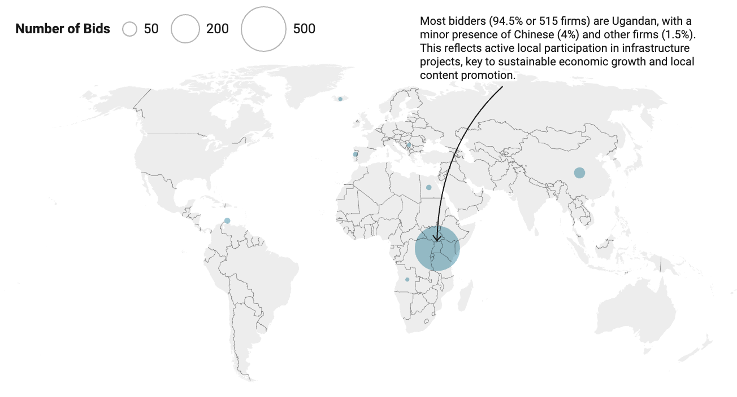

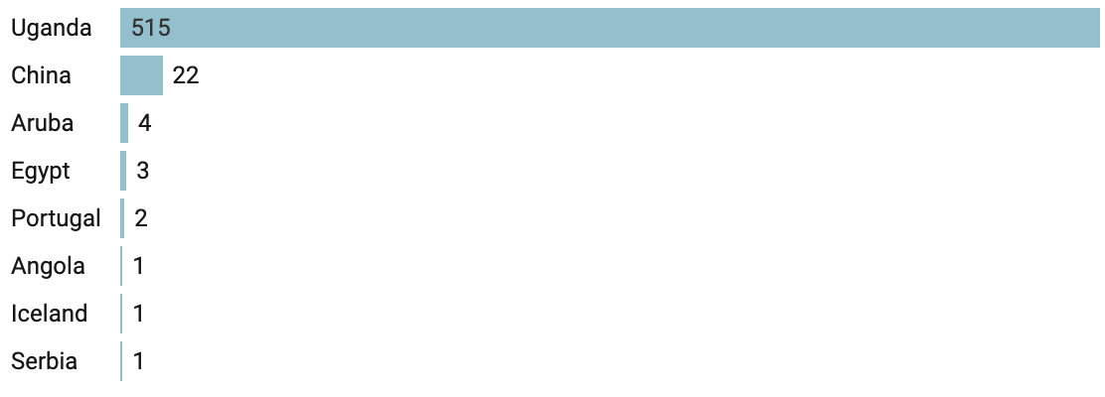



### 4.3.5 Most frequently winning providers per PDE

As shown in Table 3, three firms: Lusa construction & Engineering Co. Ltd (N = 38, 51%) from Uganda National Roads Authority (UNRA), DingXIANG East Africa Enterprises Limited (N = 9, 12%) from Ministry of Agriculture, Animal Industry and Fisheries, and Empa Associates Ltd (N = 9, 12%) from Ministry of Works and Transport won significantly more contracts. On average, excluding Lusa construction & Engineering Co. Ltd (that appears extreme), the rest of the firms won hardly two contracts (Average = 1.8) in the period under review. The data depicts a lack of a fair distribution of contracts in the construction sector as some firms win only one contract. Table 3 presents the results of the analysis.

**Table 3: Most frequent winning providers per PDE**

|  |  |  |  |
| --- | --- | --- | --- |
| **Entity** | **Provider Name** | **Frequency** | % |
| Kiboga District Local Government | Kevin & Keith Investments Ltd | 2 | 3% |
| Makerere University | CK Associates Limited | 1 | 1% |
| Ministry of Agriculture, Animal Industry and Fisheries | DingXIANG East Africa Enterprises Limited | 9 | 12% |
| Ministry of Energy and Mineral Development | Good news | 1 | 1% |
| Ministry of Health | Arc Civil Engineering (U) Ltd | 1 | 1% |
| Ministry of Works and Transport | Empa Associates Ltd | 9 | 12% |
| National Agricultural Research Organization | Continuum engineering Ltd | 1 | 1% |
| National Social Security Fund | Creark Group Ltd | 1 | 1% |
| Uganda Communications Commission | CLS Limited | 1 | 1% |
| Uganda National Roads Authority | Ambitious Construction Co. Ltd | 2 | 3% |
| Uganda National Roads Authority | Lusa construction & Engineering Co. Ltd | 38 | 51% |
| Uganda National Roads Authority | Dynaco limited | 4 | 5% |
| Uganda National Roads Authority | NIPE construction Ltd | 4 | 5% |
| Total | | 74 | 100% |

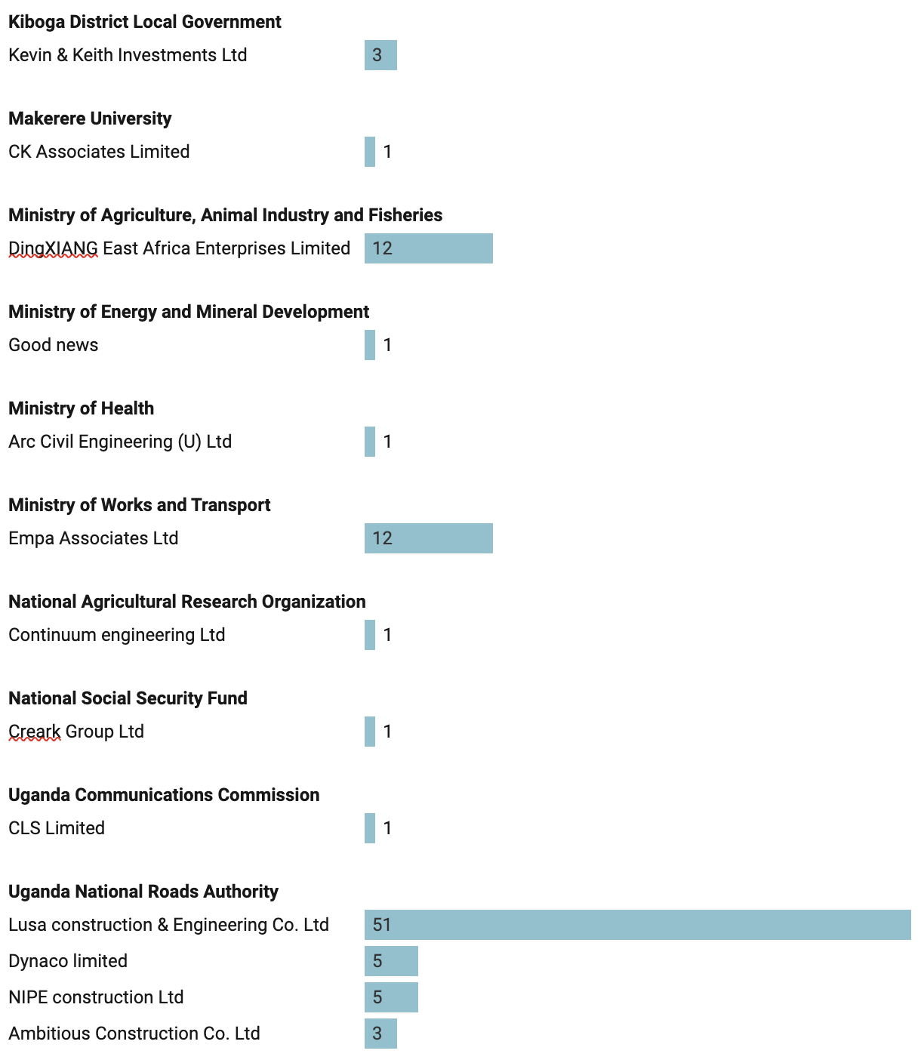

As shown in Table 3, the three firms (Lusa construction & Engineering Co. Ltd, DingXIANG East Africa Enterprises and Empa Associates Ltd) won 51%, 12% and 12%, respectively. Together, the three firms accounted for 75% of the contracts awarded. While the winners could be due to competitive pricing, quality works, or other factors; the phenomenon should be systematically studied to verify and document the competence of the winning firms. The results would help mobilize and build the capacity of bidders who frequently fail to win tenders.

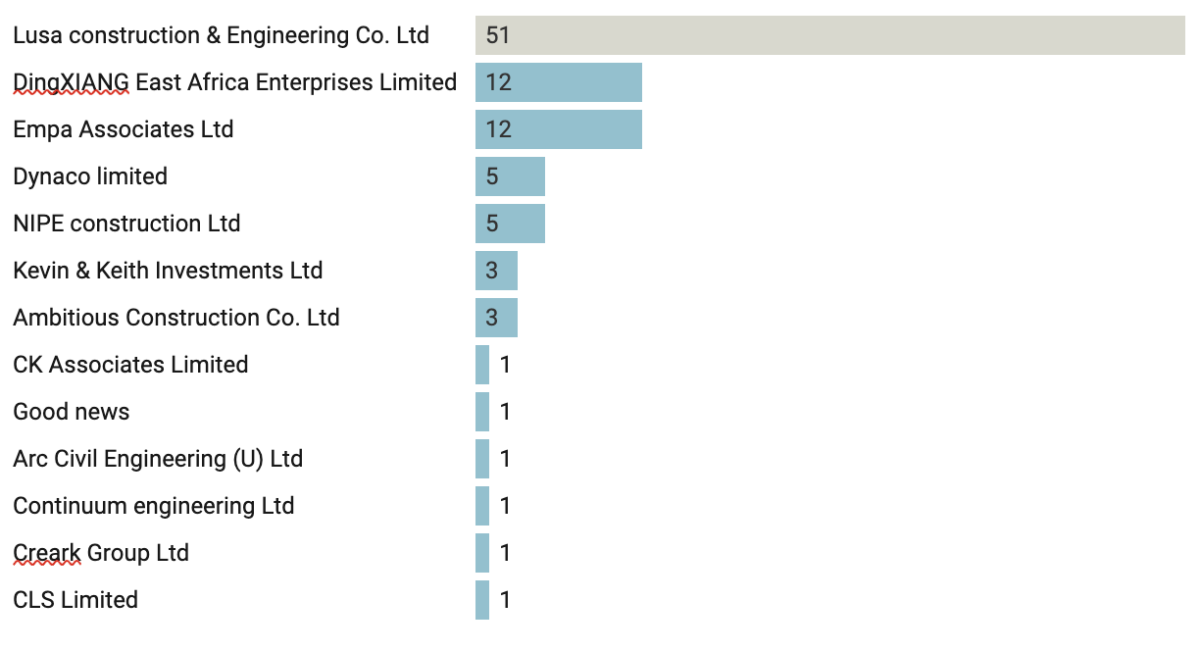

Figure 3: Most frequent winning providers per PDE

**4.3.6 Most frequently losing providers per PDE**

Table 4 presents the number of times certain bidders lost bids in the respective PDEs during the period under review. A higher frequency suggests the individual firm lacks contractual and/or technical capacity, which often includes equipment and tools of the right quality and quantity, financial capacity, personnel, experience in similar work, etc.

As illustrated in Table 4, TMS Engineering Ltd was the most frequent loser of tenders (nine times) in Uganda National Roads Authority, and followed by Munda Holdings Ltd (three times) in Kiboga District Local Government.

|  |  |  |
| --- | --- | --- |
| **Entity** | **Provider Name** | **Number** |
| Kiboga District Local Government | Munda Holdings Ltd | 3 |
| Makerere University | Open World Contractors Limited | 1 |
| Ministry of Agriculture, Animal Industry and Fisheries | MS Niem Establishment LTD | 1 |
| Ministry of Energy and Mineral Development | AEA Ltd | 1 |
| Ministry of Works and Transport | King Albert Construction Ltd | 2 |
| National Agricultural Research Organization | CMD Investment Ltd | 1 |
| National Social Security Fund | Creark Group Ltd | 1 |
| Uganda Communications Commission | EarthLink Solutions Ltd | 1 |
| Uganda National Roads Authority | TMS Engineering Ltd | 9 |

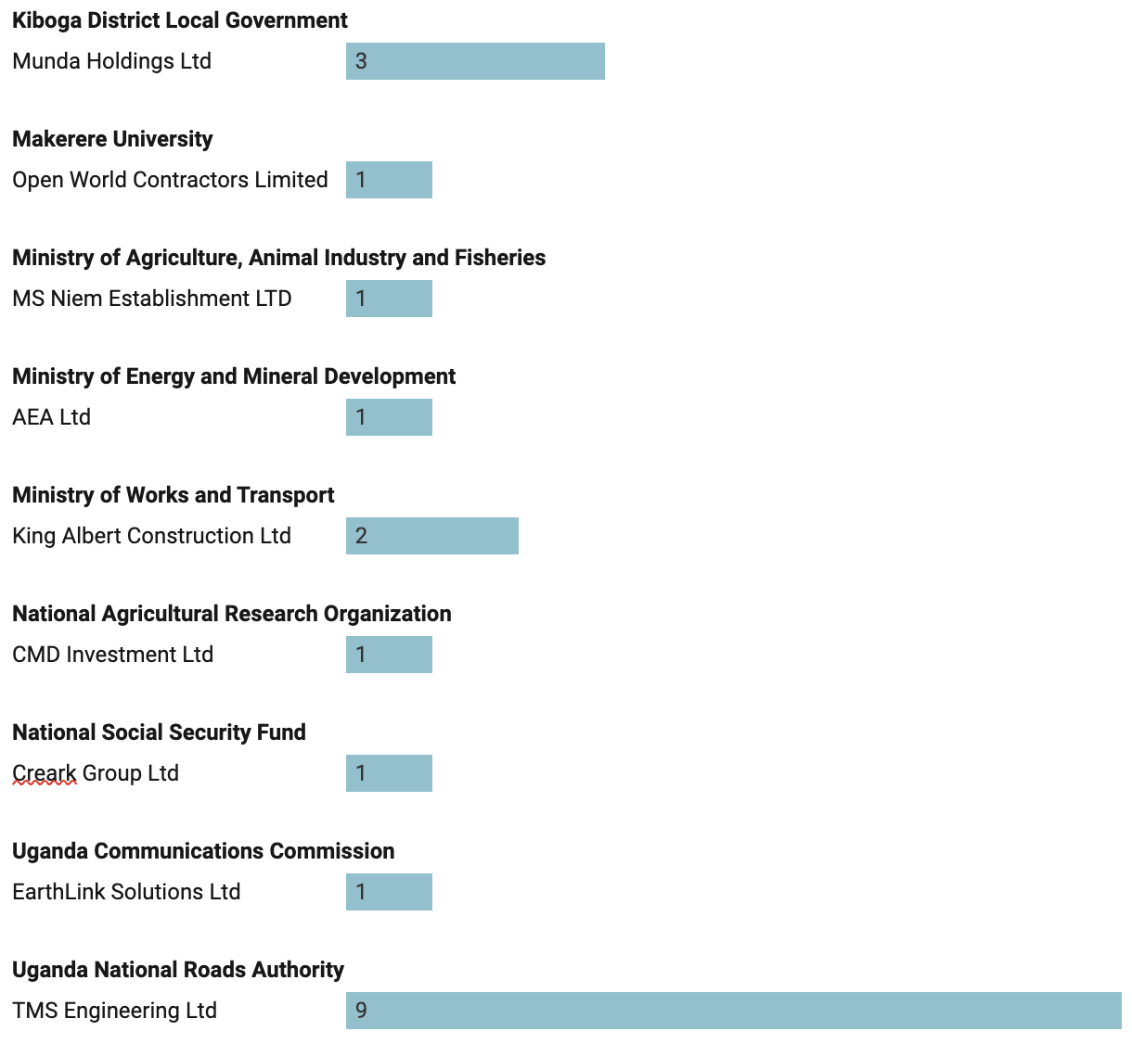

As a best practice, losers of bid opportunities should be debriefed. Through debriefs, bidders can understand their weaknesses and design strategies to address them. Debriefing is buttressed under PPDA Regulations (Procuring and Disposing Entities) Regulations, 2014, Reg. 33(2) (f). The provision obligates entities to display notices of best evaluated bidders, including the unsuccessful ones, showing reasons for rejection. Nonetheless, the common reasons for rejection of bids range from lack of legal capacity to technical capacity, such as experience, equipment and tools, financial capacity, human resources, and so forth. Figure 5 presents bidders and the times they had lost tenders during the period under review.

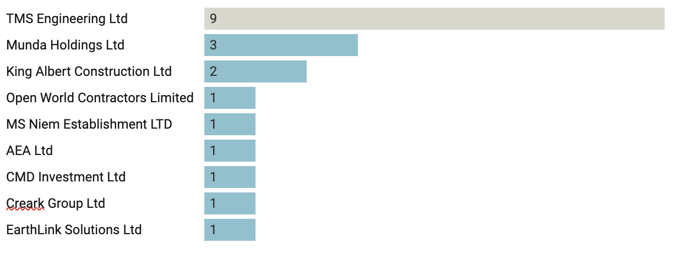

**Figure 4****: Most frequently losing providers per PDE**

### 4.3.7 Percentage of tenders with less than three bids

Data on GPP for the period under review shows that the percentage of tenders from competitive procurement methods with less than three bids was approximately 39.13%. That is, four in 10 tenders attracted less than three bids. This proportion is quite high and should be reduced to spur competition which leads to reduced costs for the procuring entity, improve transparency and reduce supplier risks, thereby fostering value for money.

### 4.3.8 Variations in award price and market price

Section 26(5) (PPDA Act 2003 (as amended) prohibits an Accounting Officer to sign a contract for a procurement where the price quoted by the best evaluated bidder is higher than the market price. This offence, on conviction, has a fine not exceeding one thousand currency points (UGX 20 million shillings) or imprisonment not exceeding five years, or both. In addition to the fine, the convict may be ordered by court to make a refund of an amount equivalent to the difference in price between the price paid for the supplies, services or works and the market price. Table 5 presents the results of the analysis.

**Table 5: Contracts whose Award Value is greater that the Market Price**

|  |  |  |  |  |  |  |
| --- | --- | --- | --- | --- | --- | --- |
| **Title** | **PDE** | **Market Price**  **(UGX)** | **Award Amount (UGX)** | **% variation** | **Provider Name** | **Date of Display** |
| Design and build of Kisoro - Rubuguri - Muko/Nteko Road Upgrading Project (72km) | UNRA | 508,383,133,900 | 581,269,182,208 | 14% | Dott Services Limited | 2022-01-17 |
| Civil works for Rehabilitation of Additional Masaka Town Roads (9.3Km) | UNRA | 53,338,589,795 | 53,336,684,835 | 0% | Chongqing International Construction Corporation (CICO) | 2021-11-19 |
| Civil works for the Upgrading of Tororo-Busia Road (29km) and Muyuge and Busia Town Roads (18Km) | UNRA | 140,739,369,888 | 136,857,027,680 | -3% | China Railway 18th Bureau Group Co. Ltd | 2021-09-15 |
| Emergency Reconstruction of Saka Swamp Crossing on the Kaliro - Pallisa National Road Network under Design and Build Scheme | UNRA | 76,782,415,168 | 76,500,755,047 | 0% | Arab Contractors (Osman Ahmed Osman & Co.) | 2022-04-06 |
| Construction of Low-Cost Sealing of Selected Low Volume Roads | MOWT | 53,080,000,002 | 9,157,645,089 | -83% | Empa Associates Ltd | 2022-04-11 |

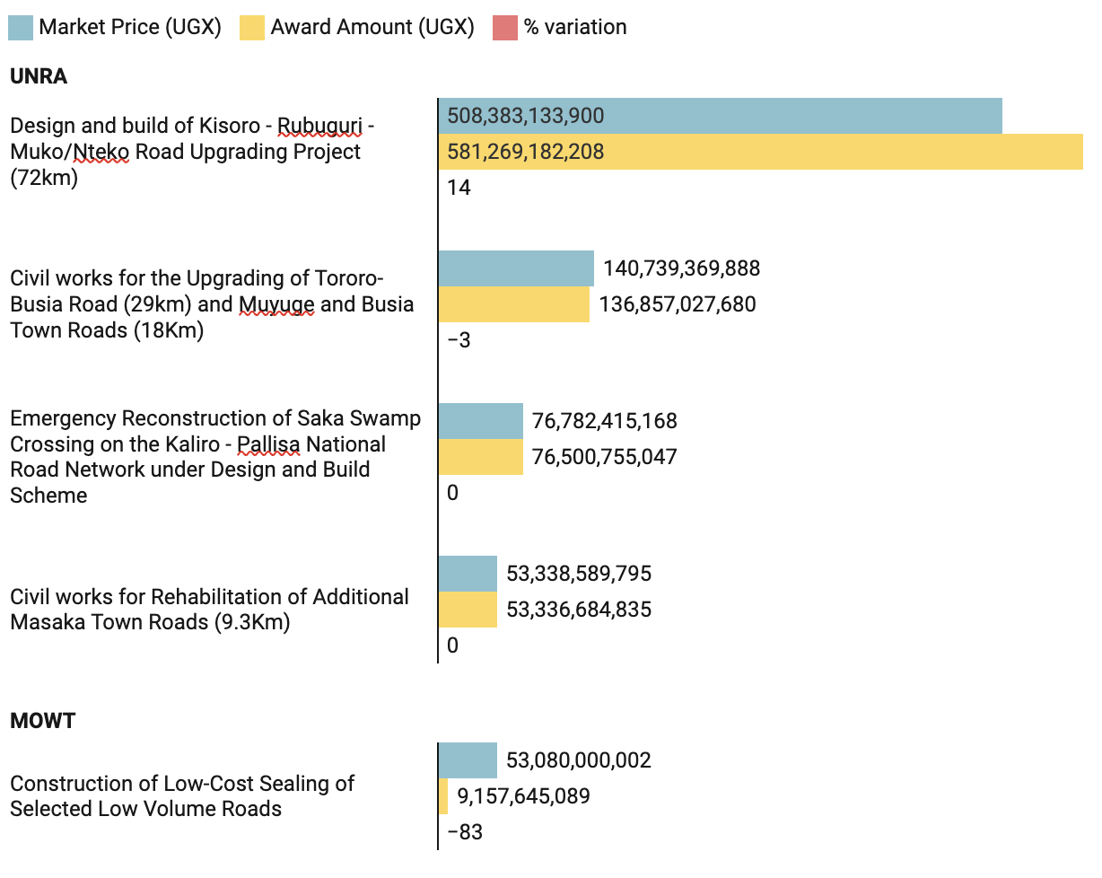

A negative percentage variation suggests the award price was below the estimated market price. Per the PPDA guideline on Thresholds for procurement methods (Guideline 1/2014), an overestimated market price of a procurement would lead to adoption of a more competitive and lengthy procurement method. Thus, the higher the estimated cost of the procurement, the more open the procurement method. The PPDA (Rules And Methods For Procurement of Supplies, Works And Non- Consultancy Services) Regulations, 2014, specifically Rules 3 and 4 provide thus:…*Where the price of the best evaluated bidder is higher than the market price established at the commencement of the procurement, the accounting officer shall re-assess the market price to ascertain that the market price is still valid. (4) Where the accounting officer ascertains that the market price established at the commencement of the procurement is still valid, the procurement shall be cancelled and re-tendered.”*

In Table 5, the Project to Design and Build of Kisoro - Rubuguri - Muko/Nteko Road Upgrading Project (72km) had a variation of 14% and *therefore required* re-assessment of the market price for the project was conducted to ascertain the validity of the market price to warrant continuation of the procurement in line with Regulation 5(4). An award above market price undermines the basic principles of economy and value for money expected of any public procurement.

## **4.4 Integration of OC4IDS in EGP**

Electronic Government Procurement (EGP) is part of the reforms to make the public procurement system more efficient and accountable. The system seeks to fully automate the public procurement process and enables the interactions of Government to business services (G2B). By using the online system, the Government purchases goods, works, services and non-consultancy services to help Government to ensure efficiency of public procurement with the standardization of electronic documents, supplier registration, goods and services information and to streamline public procurement transactions for efficient government service delivery.

Upon full implementation, EGP will offer providers with increased access to business opportunities without additional marketing efforts and a faster and more efficient method for quoting and increased order accuracy through receipt of electronic orders. To-date, the Ministry of Finance, Planning and Economic Development (MOFPED), through the Department of Procurement Policy Management are in the process of integrating the Open Contracting for Infrastructure Data Standards (OC4IDS) in EGP. Upon integration, EGP will publish standardized data on infrastructure projects and contracts using the CoST Infrastructure Data Standards (IDS). and the Open Contracting Data Standard (OCDS). OCDS is is a free, non-proprietary open data standard for public contracting, implemented by over 30 governments around the world. It describes how to publish data and documents about contracting processes for goods, works and services.

Open contracting is about publishing and using open, accessible, and timely information on government contracting to engage citizens and businesses in identifying and fixing problems.Importantly, open contracting consists of disclosure and engagement throughout the entire chain of procurement, including planning, tendering, awarding, and implementation. The Ministry of Finance, Planning and Economic Development working with Honeycomb Technologies Limited, the company contracted to develop, support, and maintain the EGP system in Uganda are undertaking the integration process. Integrating OC4IDS in EGP is part of the developer's milestone in the contract. However, the developer will embark on the integration process upon conclusion of the Business Process Re-engineering and the review of EGP regulatory framework. Once the integration is concluded, the public will be able to access the following data through the EGP portal;

**Table 6: OC4IDS Project Level information**

|  |  |  |  |
| --- | --- | --- | --- |
| Category |  |  |  |
| Budget data points | Amount  currency  Request date  Approval date  Budget break down  Description  Amount  Currency  Period  Source party name | Document data points | Description  Title  Date published  Date modified  Page start  Page end  Access details  Author  Document type |
| Location data points | Description  Coordinates  Website  Address | General information data points | Title  Description  Status  Start date  End date  Sector  Purpose  Project type |
| Completion data details | End date  End date details  Final value  Final value details  Final scope details | Parties involved data points | Name  Address contact  Contact point  Email  Telephone  Wibe site  Role |

**Table 7: OC4IDS Contract level information**

|  |  |  |  |
| --- | --- | --- | --- |
| **Category** |  |  |  |
| Tender Data points | 1. OCDS id 2. Nature 3. Title 4. Description 5. Status 6. Procurement Method 7. Cost Estimate 8. Currency 9. Number of Tenderers 10. Procuring Entity 11. Administrative Entity 12. Supplier name 13. Supplier ID | Modification Data points | 1. Date 2. Description 3. Rationale 4. Type 5. Old Contract Value Amount 6. Old Contract Value Currency 7. New Contract Value Amount 8. New Contract Value, Currency 9. Old Contract Period start Date 10. Old Contract Period end Date 11. Old Contract Period max Extent Date 12. Old Contract Period duration in days 13. New Contract Period start Date 14. New Contract Period end Date 15. New Contract Period max Extent Date 16. New Contract Period duration in days |

|  |  |  |  |
| --- | --- | --- | --- |
| Contract data points | OCDS id  Amount  Currency  Contract Start Date  Contract End Date  Maximum extension date  Cost Estimate  Currency  Duration in days  Final Value  Final value Currency | Release data points | 1. Planning 2. Planning Update 3. Tender 4. Tender Amendment 5. Tender Update 6. Tender Cancellation 7. Awards 8. Award Update 9. Award Cancellation 10. Contract 11. Contract Update 12. Contract Amendment 13. Implementation 14. Implementation Update 15. Contract Termination 16. Compiled qualification 17. Qualification update 18. Qualification Amendment 19. Qualification Cancellation 20. Shortlist 21. Shortlist Update 22. Uri 23. Date |
| Documents data points | Description  Title  Date published  Date modified  Page start  Page end  Access details  Author  Documents type |

# **5.0** **SUMMARY OF KEY FINDINGS**

1. **There was a low bidder response** to open tenders for public infrastructure projects, with an average of 1.38 bids received per bid opportunity.
2. **Most contracts** (75%) were awarded through the open domestic bidding method, suggesting increasing domestic capacity.
3. **Most bidders** (94.5%) were Uganda firms, implying high compliance by PDEs to reservation schemes that seeks to enhance local content in public procurement (Guideline 1/2018).The guideline provides for a reservation of procurement of road works whose estimated cost is UGX 45 Bn and below, and other public works whose estimated cost is UGX 10 Bn and below to national and resident providers.
4. **Thirty nine percent (39%), that is, about four in 10 tenders had attracted** less than three bids, suggesting low bidder response to tenders.
5. There were some cases of variations between market price and contract award prices in some projects, for example, in the Design and Build of Kisoro - Rubuguri - Muko/Nteko Road Upgrading Project (72km), a variation of up-to 72.8 Bn (14%) was observed.
6. **Integration of OC4IDS in EGP is yet to be concluded.** The activity is pending conclusion of EGP regulatory framework by the Attorney General.
7. There was no data on GPP to support spend analysis, delays, and quality of delivered projects. Similarly, GPP did not capture data on details of persons (firm or individuals) who are award contacts such as women, Youth or Persons with Disabilities (PWDs). Yet, inclusive procurement should be a deliberate way to integrate all citizens in the money economy.
8. There is no data providing for geo-mapping of projects, this is because of lack of a legal requirement to geomap projects, requiring entities to report and disclose on coordinates of the projects to establish the actual location of planned and completed projects on a live map.

# **6.0** **SUGGESTED RECOMMENDATIONS**

1. The extant analysis revealed that most bidders (94.5%) were Uganda firms. PPDA should therefore initiate sector-wide information dissemination on the planned projects, implementation status, expected outputs, funding details, and cost to consolidate this level of achievement. Besides the entity websites, such strategic information should be disseminated through local and national radio stations, TVs, social media platforms, etc. Moreover, Section 58 (6) of the PPDA act obligates entities to display procurement plans on notice boards for at least 20 working days.
2. **The low response to tenders, with 39% of the tenders attracting** less than three bids, and the **low average number of bids per open tender (1.38 bids) a**ffirms the existence of barriers to private sector participation in public tenders. PPDA should work towards reducing procurement transaction costs to enhance private sector participation in public sector procurement. Entities should be closely monitored to ensure they commit to non-discrimination while setting qualification requirements to avoid artificially restricting competition. Factors such as the cost of bidding documents, limited information on available tenders, delays in payments, and corrupt and fraudulent practices in award of tenders have repeatedly been cited as impediments to private sector participation in government tenders.
3. PPDA should decisively address the issue of variations between market price and contract award prices of projects, especially those considered strategic to national development. The current role of PPDA in procurement planning under Section 58 of the PPDA Act should be reviewed to include an analysis of the estimated costs therein relative to market prices. It is hoped this initiative would proactively reduce the occurrence of budget overruns that seriously affect project implementation.
4. PPDA should issue a legal provision or amend reporting templates to include a requirement for entities to report on location and coordinates of planned and completed projects. This should further be effected by MoFPED in the design of the e-GP.
5. Numerous data points were missing, suggesting entities do not post complete data on GPP, which made the computation of some vital indicators like delays, cost overruns, and spend analysis difficult. PPDA, through her periodic inspections vide s.7 (1) (I) of the PPDA Act 2003(as amended), should enforce records management and disclosure on GPP by all entities. Without a strategic view of procurement and contract management records, performance gaps and indeed red flags will be difficult to monitor and address.
6. The Ministry of Finance, together with PPDA, should expedite the integration of OC4IDS in the EGP to foster transparency and real-time access to infrastructure procurement information. For tender opportunities, these should be sent directly to the registered bidders.
7. CoST should continue her advocacy for access to information, open government, and open contracting. To this effect, CoST should support CSOs and the public as a whole to access the required information, be it electronic or physical espcially through the dashboard. Some members of the public quite often lack the skills to mine the data they need.
8. Part of the reason for the low bidder response to infrastructure tender invitations has for a long time been due to the inherent limited capacity, especially of local contractors, to effectively cost and implement infrastructure projects successfully. Therefore, Government should create a Construction Industry Development Fund, currently under pursuit by the Uganda National Association of Building and Civil Engineering Contractors (UNABCEC). Otherwise, the current interest rates for commercial loans in the range of 20-25% are outrageous and make local firms uncompetitive compared to their counterparts, especially from China, where capital is accessed under 10%.

# **7.0 REFERENCES**

Cost Uganda (2017). Country Scoping Study Report On the Infrastructure Data Standards.

Cost Uganda (2018). 2nd Assurance Report for Cost Uganda.

Cost Uganda (2019). 3rd Assurance Report for Cost Uganda.

Cost Uganda (2020). Promoting Fair Business Practices through Open Data: An Analysis of Infrastructure Data disclosed on the GPP for Selected PDEs using the Cost Infrastructure Data Standard and OC4IDS indicators

Cost Uganda (2021). A ray of sunshine. 4th Assurance Report for Cost Uganda.

Department for Transport, UK (2015). Value for money. Moving Britain ahead. Available on https: // assets.publishing.service.gov.uk /government /uploads /system/uploads/attachment_data/file/918479/value-for-money-framework.pdf

Kyogabirwe, L (July, 2017). CIPESA (Promoting effective and inclusive ICT policy in Africa. Access to Public Information in Uganda: Rhetoric or Reality?

Ministry of Finance, Planning and Economic Development (2020). The National Public Procurement Policy.

OECD (2017). Procurement and the delivery of infrastructure projects. In Government at a Glance 2017. OECD Publishing, Paris.

OECD. (n.d). Public Procurement for Sustainable and Inclusive Growth. OECD Publishing.

Procurement and Disposal of Public Assets (PPDA) (Evaluation) regulations, 2014

Procurement and Disposal of Public Assets (PPDA) (Rules and Methods for Procurement of Supplies, Works and Non-Consultancy Services) Regulations, 2014

Procurement and Disposal of Public Assets (PPDA) (Thresholds for Procurement Methods) Guideline 1, 2014

Procurement and Disposal of Public Assets (PPDA) Act, 2003 (as amended).

Public Procurement and Disposal of Public Assets Authority (2020). Strategic plan 2020/21-2024/25.

Public Procurement and Disposal of Public Assets Authority (2020). The 4th Procurement Integrity Survey.

The Local Governments (Public Procurement and Disposal of Public Assets) Regulations, 2006

The Local Governments Act Cap 243

Torrisi, G. (2009). Public infrastructure: definition, classification, and measurement issues. The University of Catania, Faculty of Economics, DEMQ, Italy.

1. <https://gpp.ppda.go.ug/public/open-data/oc4ids/project-summary>